



Long Term Financial Plan

2024-2034

Contents

1 Our Long Term Financial Plan 3

2 Message from the CEO 4

3 City Profile 5

3.1 Our Region 5

3.2 Key Statistics 5

4 Integrated Strategic Planning 6

4.1 Background 6

4.2 Strategic Directions 6

5 Our Services 7

5.1 Service Programs 7

5.2 Service Levels 8

5.3 Managing Our Assets 9

6 Key Financial Strategies and Policies 10

6.1 Rating Income Strategy 10

6.2 Cash Reserves 11

6.3 Balancing the Budget 12

6.4 Cost Recovery of Services 13

6.5 Prudent Investment and Use of Debt Finance 13

7 Workforce Planning Strategy 14

8 Scenario Modelling and Sensitivity Analysis 15

9 Measuring Sustainability 16

9.1 Key Performance Indicators 16

10 Key Assumptions underpinning our LTFP 21

10.1 Operational Revenue and Expenditure 21

10.2 Economic Assumptions 21

10.3 Capital Works Program 22

10.4 Housing Initiatives 23

10.5 Exclusions 23

11 Key Risks to Long Term Sustainability 23

12 Financial Projections 24

12.1 Financial Statements 24

13 Implementation and Review of the Long Term Financial Plan 25

14 Appendices 26

14.1 Appendix A - Financial Statements 26

Statement of Comprehensive Income by Nature and Type 26

Statement of Cash Flows 27

Rate Setting Statement 28

Statement of Financial Position 29

Statement of Equity 30

14.2 Appendix B – Supporting Schedules 31

Twenty Year Capital Works Program 31

Loan Repayment Schedule 32

Cash reserves 32

Sustainability Ratios 33

14.3 Appendix C - Important Documents and Policies 34

14.4 Appendix D - Glossary 35

# Our Long Term Financial Plan

The City of Karratha is committed to transparent, responsible and accountable financial management. To achieve this, in 2009 the City implemented the Integrated Planning and Reporting Framework introduced by the Department of Local Government, which requires all Western Australian local governments to prepare a long term financial plan linked to a Strategic Community Plan and a Corporate Business Plan.

The City of Karratha’s Long Term Financial Plan (LTFP) is a key resource that facilitates the delivery of the identified priorities made in our Strategic Community Plan. It enables the City to set priorities based on its financial resources.

As such, the LTFP is a critical document that underpins and influences the direction of the City’s spending and investment now and going forward.

The LTFP, along with information contained in other strategic plans including the Strategic Asset Management Plan and Workforce Planning Strategy, form the basis for preparation of the City’s Annual Budgets. The LTFP is reviewed annually, updating the current forecasts out to 2034.

The following plan provides an overview of the City’s LTFP including our current financial position, approach to financial planning, revenue sources and the long-term projects we are working to deliver to benefit our community over the next 10 years to ensure the City’s long term sustainability.

The following figure illustrates how the LTFP informs the Integrated Planning and Reporting Framework.

Outputs: Plan Monitoring and Annual Reporting

# Message from the CEO

At the City of Karratha, our goal is to become Australia’s most liveable regional city, and this vision is supported by our Long Term Financial Plan.

We have made significant progress over the years, delivering essential upgrades to our infrastructure and facilities while enhancing service delivery.

Our Strategic Community Plan provides the framework for our vision, supported by the Long Term Financial Plan, which outlines how we will allocate resources over the next decade, details major infrastructure projects, and presents our financial position and projections.

Despite the progress we've made, it remains crucial to continue addressing the barriers to livability in Karratha. The city is facing a unique and unpredictable housing market.

Addressing the shortage of residential properties and finding ways to strengthen the local construction industry is a priority, particularly given the billions in infrastructure investment and anticipated population growth in the coming years.

To achieve this, we are advancing several projects aimed at improving the livability of our region. These include Project Dorothy and the Walgu Development to increase available housing, as well as key infrastructure initiatives like the Kevin Richards Memorial Oval Redevelopment, the Roebourne Streetscape Masterplan, and place plans for all our towns.

One of the main challenges for the Council in the coming years will be to remain prominent in the minds of key decision-makers and funding partners, ensuring that the improvements we have made continue rather than become the only changes we see in the City.

The City of Karratha is in a strong financial position, with a solid framework in place. However, responding to changing circumstances through prudent financial management remains essential.

Virginia Miltrup

CEO, City of Karratha

# City Profile

## Our Region

The City of Karratha (the City) is located approximately 1,535km north of Perth in the dynamic Pilbara region of Western Australia. The City encompasses a total land area of 15,882 square kilometres and is home to approximately 24,237 residents across the five town sites of Karratha, Dampier, Roebourne, Wickham and Point Samson, plus the historic village of Cossack.

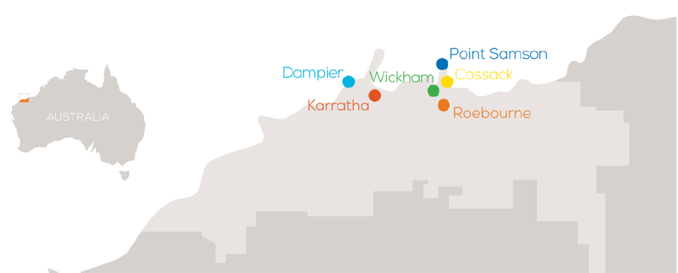

The northwest Australian coastline between Broome and Exmouth is the most cyclone-prone region of the Australian coastline and has the highest frequency of coastal crossings, according to the Bureau of Meteorology. The Australian cyclone season extends from November 1 to April 30. On average, five tropical cyclones occur during each season over waters off the northwest coast. Due to the City’s location within the cyclone zone, it is critical for the City to be able to swiftly respond to damage sustained by severe impacts.

The City of Karratha is a growing regional centre within the Pilbara, with residents enjoying a myriad of outdoor activities, festivals and community events year-round, as they make the most of the warm weather and coastal location.

Over the past 40 years the City of Karratha has been a powerhouse of economic growth for Western Australia and the nation. The City of Karratha has a robust economy that includes contributions to Australia’s world leading exports of both iron ore and liquefied natural gas (LNG).

Future levels of population growth in the City of Karratha are largely dependent on the performance of the mining sector, new projects and the size of the Fly In Fly Out workforce.

## Key Statistics

| Key General Statistics | |  | Key Financial Statistics (2023/2024) | |
| --- | --- | --- | --- | --- |
| Distance from Perth | 1,535km |  | Rates revenue | 54,861,525 |
| Area | 15,882km |  | Fees and charges | 62,297,368 |
| Estimated residential population | 27,608 |  | Operating revenue | 140,081,648 |
| Employed residents | 14,910 |  | Operating expenditure | 121,843,674 |
| Number of City employees (FTE) | 376 |  | Net assets | 868,939,846 |
| Rateable properties | 10,247 |  | Cash backed reserves | 115,590,640 |

# Integrated Strategic Planning

## Background

The Integrated Planning and Reporting Framework outlines the method to achieve a sustainable local government through adopting a holistic approach to planning and reporting.

It involves improving integration of various statutory planning and reporting processes undertaken by the local government through streamlining business and reporting processes with the involvement of the community.

A key element of the Integrated Planning and Reporting Framework is the Long Term Financial Plan. It enables the City to set priorities, based on resourcing capabilities for short, medium and long term delivery of the community’s requirements.

## Strategic Directions

*Our Vision: Australia’s most liveable regional city*

The principal guidelines for the Long Term Financial Plan are provided by the City of Karratha Strategic Community Plan.

The Strategic Community Plan 2020-2030 outlines the future of the City of Karratha over a 10-year period, focusing on the development and support of our local community, the growth of our economy and building a sustainable, attractive and exciting place to live, work and play.

The objective of a Strategic Community Plan is to engage the community in planning for the future of the local government area. It involves setting priorities with the community for the future through aligning the community’s vision with a clear strategic direction for the City.

The Strategic Community Plan comprises four key strategic pillars. These themes form the basis of the identified priorities and include our:

* Community – *inclusive and engaged*
* Economy – *well managed and diversified*
* Environment – *thriving and sustainable*
* Leadership – *proactive and accountable*

The Long Term Financial Plan is an informing strategy to assist with recognising financial resources required for achieving the vision of being *Australia’s most liveable regional city.*

**OPERATIONAL PLAN**

**CORPORATE BUSINESS PLAN**

**STRATEGIC COMMUNITY PLAN**

Themes

Goals

Outcomes

Our Response

**Asset Management Plans**

**INFORMING STRATEGIES**

Strategic Priorities

**Long Term Financial Plan**

**ANNUAL REPORT**

Actions

Projects

Budgets

**Workforce Plan**

Ongoing monitoring and review

# Our Services

## Service Programs

The City of Karratha is responsible for providing a range of infrastructure and services to the community which fall into the following programs prescribed under the *Local Government Regulations 1996*.

In order to discharge its responsibilities to the community, Council has developed a set of operational and financial objectives. These objectives have been established on an overall basis, reflected by the City's Community Vision, by Directorate, and for each of its broad activities/programs and business units.

Estimates of expenditure and income have been calculated for each of these programs in the Long Term Financial Plan, and allocated across the various business units that make up the City.

| Program | Explanation |
| --- | --- |
| **Governance** | **Objective:** To provide a decision making process for the efficient allocation of scarce resources.  **Activities:** Includes the activities of members of council and the administrative support available to the council for the provision of governance of the district. |
| **General Purpose Funding** | **Objective:** To collect revenue to allow for the provision of services.  **Activities:** Rates (including ex-gratia contributions), general purpose government grants and interest and investment revenue. |
| **Law, Order, Public Safety** | **Objective:** To provide services to help ensure a safer and environmentally conscious community.  **Activities:** Supervision and enforcement of various local laws relating to fire prevention, animal control and other aspects of public safety including emergency services. |
| **Health** | **Objective:** To provide an operational framework for environmental and community health.  **Activities:** Inspection of food outlets and their control, provision of meat inspection services, noise control, mosquito control and waste disposal compliance. |
| **Education and Welfare** | **Objective:** To provide services to disadvantaged persons, the elderly, children and youth.  **Activities:** Maintenance of childminding centres, playgroup centres, senior citizen centres and aged care centres. |
| **Housing** | **Objective:** To provide and maintain staff housing.  **Activities:** Maintenance and operational expenses associated with the provision of staff housing. |
| **Community Amenities** | **Objective:** To provide services required by the community.  **Activities:** Rubbish collection services, operation of rubbish disposal sites, litter control, construction and maintenance of storm water drainage, protection of the environment and administration of town planning schemes, cemeteries and public toilets. |
| **Recreation and Culture** | **Objective:** To establish and effectively manage infrastructure and resources which will help the social wellbeing of the community.  **Activities:** Maintenance of public halls, civic centres, aquatic centres, beaches, recreation centres and various sporting facilities. |
| **Transport** | **Objective:** To provide safe, effective and efficient transport services to the community. **Activities:** Construction and maintenance of roads, streets, footpaths and cycleways, drainage, depots, parking facilities and traffic control. Includes operation and maintenance of the Karratha and Roebourne Airports. |
| **Economic Services** | **Objective:** To help promote the local government and its economic wellbeing.  **Activities:** Tourism and area promotion including the maintenance and operation of visitor services and camping grounds. |
| **Other Property and Services** | **Objective:** To monitor and control operating accounts.  **Activities:** Private works operations on properties and services not under the care, control and management of the City. Plant operations, technical services and unclassified works. |

## Service Levels

The City has produced major projects to greatly improve the level of service and amenities across our town. While there have been significant improvements to our service levels, it is proposed that service levels will continue to grow.

Significant projects on the horizon to greatly improve the level of service and amenity across our towns include:

**Facilities:**

* Upgrades and enhancements to Karratha Airport
* Upgrades and improvements to sporting facilities, in particular Kevin Richards Memorial Oval
* Foreshore and streetscape developments throughout the district, such as:
  + Roebourne Streetscape Masterplan
  + Dampier Townsite enhancement
  + Point Samson Masterplan
* Facility refurbishments and enhancements.
  + Roebourne Recreation Precinct
  + Wickham Recreation Precinct
  + Windy Ridge Sporting Precinct
  + Karratha Country Club Redevelopment
  + Karratha Leisureplex
  + Red Earth Arts Precinct

**Services:**

* Ensuring we continuously improve the level and quality of our ‘core services’ to all of our communities.
* Construction of Cell III at 7 Mile Waste Facility

**Growth:**

* Supporting industry growth in multiple sectors.
* Actively engaging in initiatives that diversify our economic base.
* Advocating for initiatives that reduce the cost of living in our district (examples include airfares, insurance, reasonable house, land and rental prices)
* Providing quality, timely approvals and advice to businesses and developers.

**Housing**

* Improving housing availability and affordability.
* Aiming to ensure sufficient land and housing available to meet community and business demand.
  + Implementation of ‘Project Dorothy’ to relieve the housing burden and promote residential housing growth

**Infrastructure**

* New and upgraded footpaths and cycleways
* New and ungraded bus shelters
* New and upgraded lighting
* Upgrades and improvements to existing roads
* Conzinc Bay Road (Murujuga National Park Entry Road)

**Community Infrastructure Plan**

The 10-year Community Infrastructure Plan includes further upgrades, expansions and new projects. This plan is already underway and includes key components such as:

* Dampier Land Transfer
* Place Planning

## 5.3 Managing Our Assets

Review of services is a continual process that is undertaken along with the associated impact to the annual budget and Long Term Financial Plan.

The City has developed a strategic approach to manage local government assets to ensure they meet the community’s current and future requirements and expectations. The Strategic Asset Management framework consists of several documents, systems and processes that address an organisation’s asset management responsibilities. These documents, systems and processes are coordinated to translate the organisation’s strategic goals, as identified in the Strategic Community Plan, into day-to-day activities.

Resilient and sustainable infrastructure assets act as a platform for economic development and meet the social and recreational needs of our local community, allowing us to deliver key services such as:

• Airport and other transport infrastructure

• Community and recreational facilities

• Waste and storm water management

• Council administration buildings

Long term maintenance and renewal of the City’s infrastructure and community assets remains a significant challenge, with increasing community expectations. The Asset Management Plan will assist the City in predicting infrastructure consumption and asset renewal needs and identify costs required to renew, upgrade or maintain the asset.

The difference between what the City spends on renewing its assets and what it needs to spend to maintain the current average condition and service level of its assets is called the renewal gap. In 2023/24 to 2024/25, planned asset renewal exceeds required asset renewal. The renewal gap is addressed in the LTFP and will be the focus of future annual budgets.

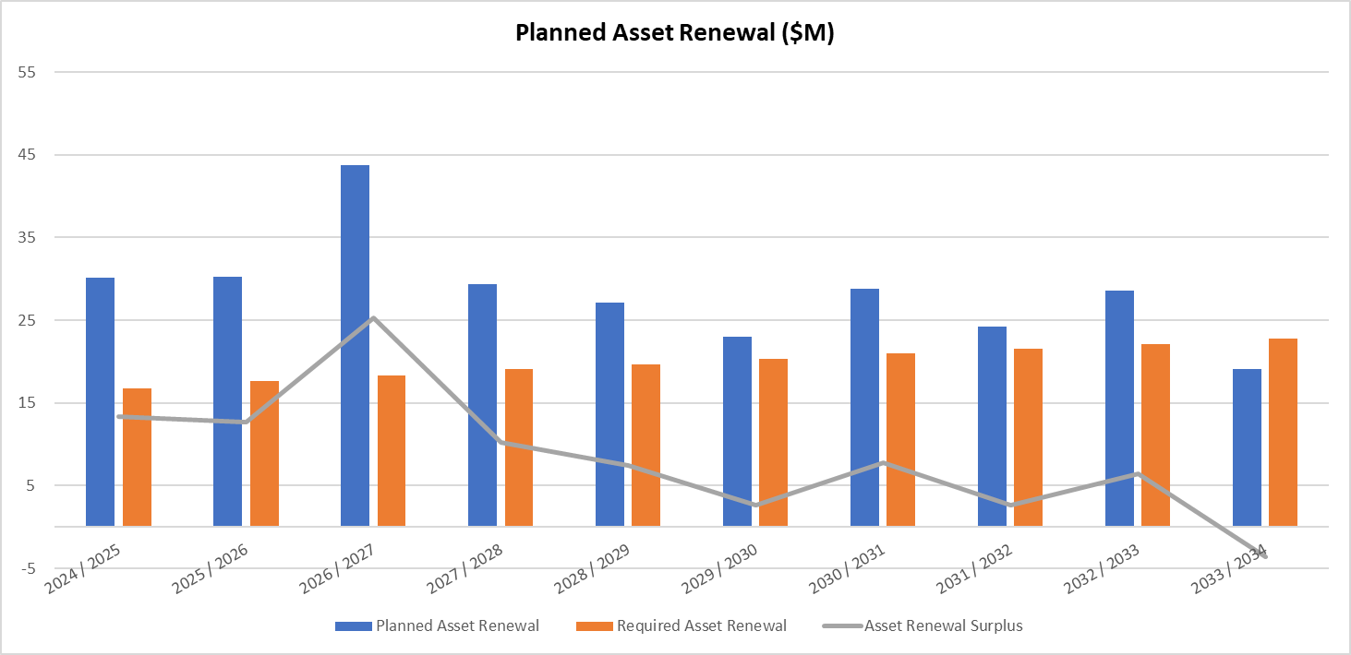

The continued funding allocated towards the renewal of assets as well as asset maintenance and upgrades, will result in a positive investment for the community in the future and ensure long term sustainability. New assets and capital works projects are funded from cash reserves, rates, airport and waste revenue, or Government grants such as Roads to Recovery.

# Key Financial Strategies and Policies

The City of Karratha’s Long Term Financial Plan is informed by a number of financial policies to ensure an accurate prediction of our financial position and our resourcing capability, to deliver on identified priorities made in our Strategic Community Plan.

Key financial strategies are detailed below.

## Rating Income Strategy

The City provides services to a diverse region consisting of residential, commercial, industrial, pastoral, mining and workforce accommodation. The City utilises differential rating on all properties within the City, based on the zoning of the property under the Town Planning Scheme. Differential rates in the dollar are set for different rating categories.

Based on the City’s rating strategy, the City applies for Ministerial Approval annually, in order to impose differential rating for all Gross Rental Value (GRV) properties and Unimproved Value (UV) properties.

The LTFP reflects a rate increase of 3.5% for 2024/25, 3.2% for 2025/26, 3.0% for 2026/2, and decreases to 2.75% for 2027/28 onwards. The rate forecast is derived from the forecasted Consumer Price Index (CPI). It is supplemented by additional rates revenue from residential land releases in Madigan, Baynton West and Bulgarra, Transient Workforce Accommodation (TWA) rates growth including Bechtel, Civeo and Perdaman camps and the increase in UV rates for the Woodside Interconnector Development.

As per the LTFP, the City will receive approximately 39.7% of its total funding from rates. To be sustainable, 40% of the City of Karratha’s expenditure each year should be met by rates revenue, as identified using the Rates Coverage Ratio. For 2024/25, this ratio is 41.9%.

Going forward, a key challenge identified in the LTFP is to reduce Council’s reliance on projected rate increases, and the continued rapid expansion of its rate base as revenue. Any decrease in rates revenue significantly impacts the City’s ability to deliver the required level of services and infrastructure.

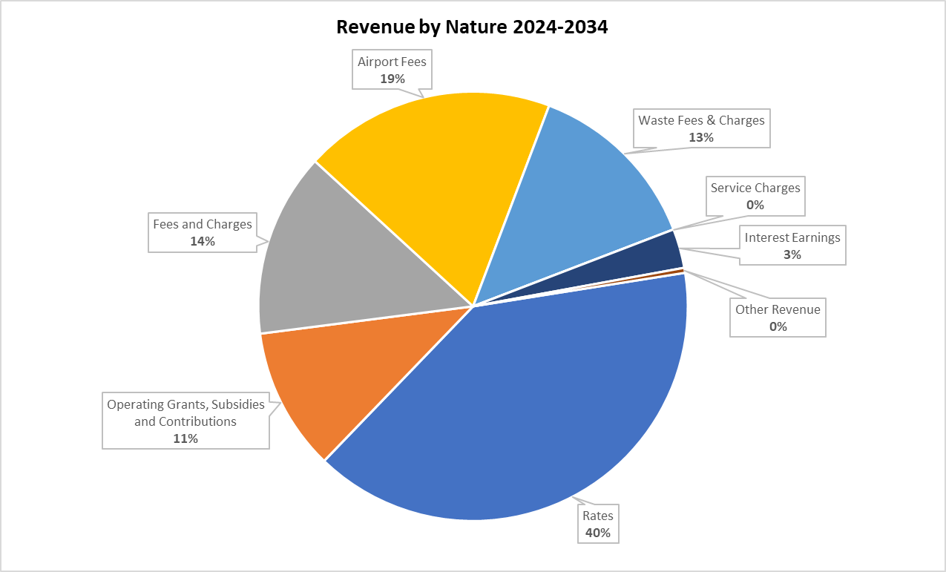

## Cash Reserves

The establishment and funding of cash reserves is a financial management strategy to ensure sufficient funds exist for future expenditure that cannot otherwise be financed during a single year, without having a material impact on the budget.

The table below outlines the various reserves Council has established and their respective purpose.

|  |  |
| --- | --- |
| Name of Reserve | Purpose of the reserve |
| Aerodrome Reserve | The purpose of this reserve is to fund the development, operation and maintenance of the Karratha Airport, inclusive of any repayments of borrowings and the funding of employee entitlements. |
| Community Development Reserve | The purpose of this reserve is to hold Annual Community Association Grant Scheme unspent payments each year and to fund future projects initiated by Community Associations from time to time via the Annual Community Association Grant Scheme. |
| Dampier Drainage Reserve | This reserve is maintained as part of an agreement between the Council and Rio Tinto (formerly Hamersley Iron). The purpose of the reserve is to ensure funds are available for the maintenance of drainage in Dampier. Rio Tinto pay to the City each year a $10,000 contribution towards this maintenance with any additional works required being drawn from this reserve and similarly, any funds remaining unspent being transferred to this reserve. |
| Economic Development Reserve | To fund economic development activities within the City, including destination marketing, business attraction, property development and tourism. |
| Employee Entitlement Reserve | To fund employee leave entitlements when on extended leave, including long service leave as well as periods of annual leave for periods greater than 4 weeks duration, thereby retaining salary and wages budgets for the funding of replacement staffing during extended periods of leave. |
| Infrastructure Reserve | The purpose of this reserve is to allow for the use of these reserve funds for the enhancement, replacement, refurbishment and purchase of infrastructure assets or project works of the City inclusive of the associated repayment of borrowings on infrastructure. Project works funded from this reserve may not necessarily belong to the City but must be carried out for the benefit of the City of Karratha. |
| Medical Services Assistance Package Reserve | The purpose of this reserve is to fund future assistance to Medical Services in accordance with Council's participation in the Medical Services Incentive Scheme. This is inclusive of retention payments to general practitioners and allied health providers in accordance with the Medical Services Incentive Scheme. |
| Mosquito Control Reserve | The purpose of this reserve is to fund mosquito control programmes inclusive of the purchase of replacement equipment as required. |
| Partnership Reserve | This reserve is maintained as part of the Community Partnership Agreement (the Partnership) and the related funding agreements between the City and Rio Tinto Iron Ore. The purpose of the reserve is to preserve funds received under each funding agreement under the partnership and restrict the funds for the purpose of each funding agreement. |
| Public Open Space Reserve | The purpose of this reserve is to fund future developments of public open space funded by contributions received in line with the *Planning and Development Act 2005.* Public open space is identified as land set aside for the purpose of public enjoyment and protection of unique environmental, social and cultural values for existing and future generations. |
| Restricted Funds Reserve | This reserve is for the purpose of holding unexpended or prepaid grants (other than Royalties for Regions) and capital contributions provided for specific purposes. |
| Waste Management Reserve | The purpose of this reserve is to fund development, rehabilitation, operation and maintenance of the City's waste management facilities inclusive of repayments of borrowings and the funding of employee entitlements. |
| Workers Compensation Reserve | The purpose of this reserve is to provide Council with sufficient funds to cover its potential liability in regard to the performance based workers compensation scheme of Local Government Insurance Services of which the City of Karratha is a member. Funds within the reserve that become surplus to requirements will be transferred to the City's Employee Entitlements Reserve via way of the City's Annual Budget. |

Over the life of the Long Term Financial Plan, cash reserves are projected to decrease from $115.6 million at the end of 2023/24 to $96.7 million in 2033/34. Reserve funds provide funding capacity for future asset renewal requirements.

As additional expenditure is known in the capital program, reserve funds will potentially be utilised.

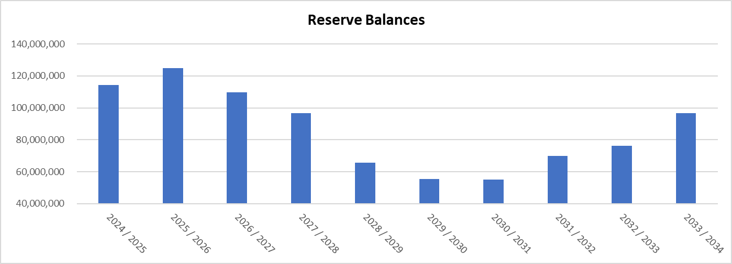

## Balancing the Budget

Generating sufficient revenue to balance the annual budget is a constant challenge, with continual improvement to the Council’s long-term financial position reliant on growth in its rates base and airport revenue.

The income gap is addressed through productivity gains and efficiency savings, pursuing grants, working collaboratively with neighbouring councils and carefully managing income and expenditure through sound financial reporting systems and regular budgetary monitoring.

The LTFP reflects this approach, however further cost efficiencies or alternative revenue sources are required to reduce the City of Karratha’s long-term reliance on projected rate increases and the continued rapid expansion of its rate base.

## Cost Recovery of Services

The adoption of a fee or charge for services and facilities is a means to recover the cost of the service provided and maintain infrastructure in a fit-for-purpose state.

The fees and charges which the City can charge fall into two categories:

* Regulatory fees - determined by State Government legislation and primarily relate to building, development, or compliance activities. Council has no control over the calculation, and any annual increases in these fees and charges.
* Discretionary fees - Council has the capacity to determine the charge or fee for discretionary works of services such as the use of community facilities and access to community services.

The general principles by which Council sets its fees and charges are that:

* Council does not intend to ‘profit’ from the setting of fees and charges;
* Fees recover the cost of services provided; and
* Fees maintain community infrastructure in a fit-for-purpose state wherein they are able to achieve expected service delivery standards.

## Prudent Investment and Use of Debt Finance

The City of Karratha’s objective around borrowing is the use of debt if appropriate to fund the cost of major new community assets or to ease the cost of major asset renewals.

Borrowings are proposed in the LTFP of $17 million for airport projects including airport terminal and carpark upgrades and the strengthening of the runway. As further capital projects commence, the option is available to the City to utilise additional borrowings to limit the reliance on Reserve funding.

Irrespective of projected and potential borrowings, our debt service coverage ratio remains high and we will have a strong capacity to repay debt within thirteen years.

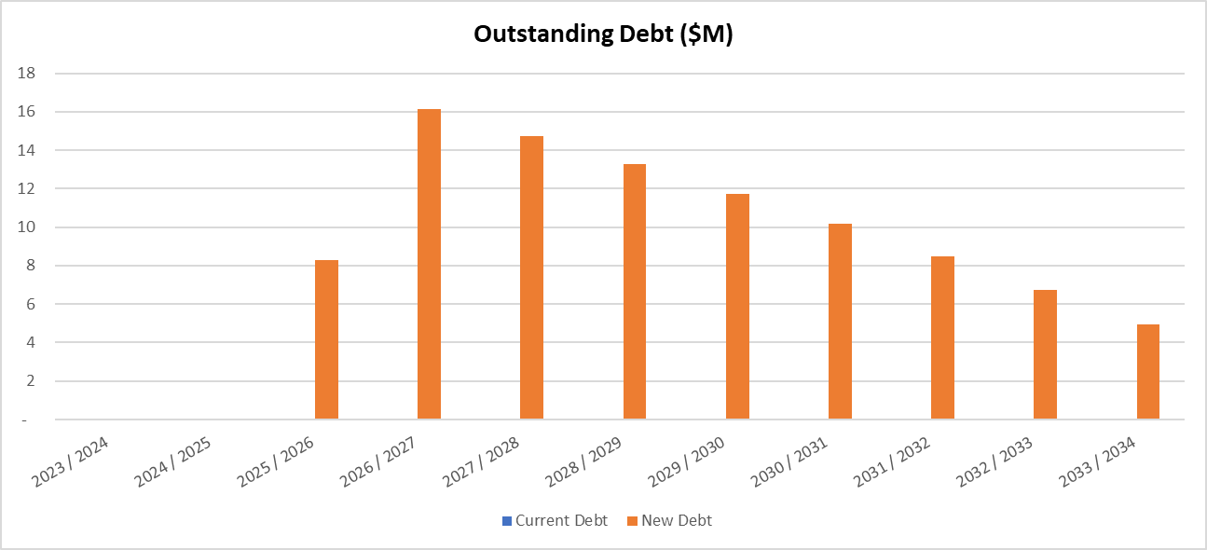

# Workforce Planning Strategy

Our Workforce Planning Strategy identifies workforce requirements and strategies for current and future operations. It is an essential component supporting the delivery of our Corporate Business Plan.

Our Workforce Plan, through recruitment, attraction and retention, succession planning, process mapping, training and housing strategies, will enable the City to plan and address, rather than just react to, business, sustainability and environmental challenges.

At 30 June 2024, the City of Karratha employed 376 full time equivalent (FTE) employees.

FTE increased in 2023/24 due to the continuing expansion of the ERP project team implementing a new IT system. The ERP project team is on a fixed term contract for the life of the project (originally estimated until 2023/2024), however with the delayed rollout of modules this term has been increased.

All new positions are subject to a business case review and the organisational structure is reviewed annually prior to adoption of each annual budget.

The below graph illustrates the projected staff until 2028-29. (Numbers are FTE only and do not take into consideration the number of casual employees or services the City of Karratha outsources to external contractors/organisations).

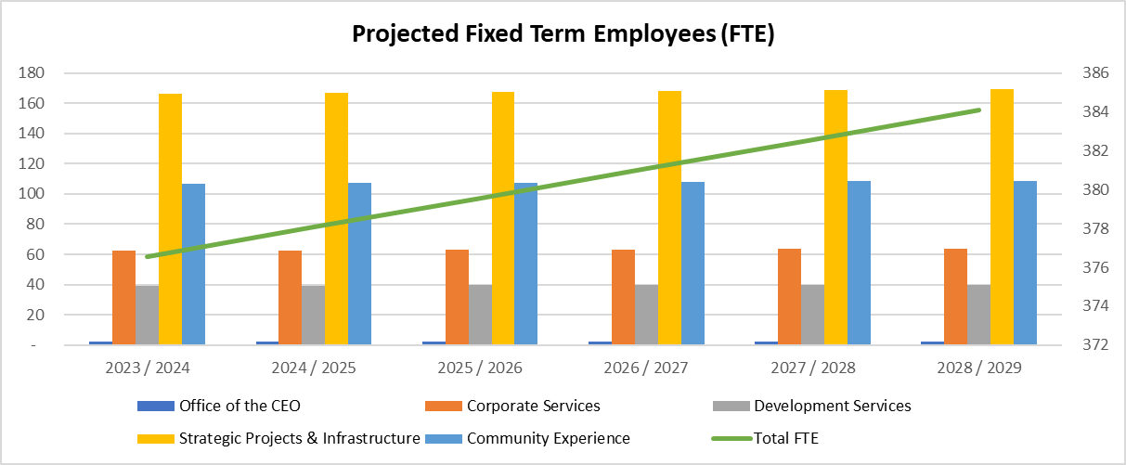

# Scenario Modelling and Sensitivity Analysis

Scenario modelling has been undertaken to determine the level of flexibility in the LTFP, to enable alternative considerations when meeting community expectations should variations occur in a range of factors or assumptions.

Three growth scenarios based on population growth were tested on each assumption to determine the City of Karratha’s capacity to deliver services and assets to the community in line with strategies outlined in the City’s Strategic Community Plan and Corporate Business Plan.

The base case scenario being a business as usual approach is based on an assessment of demand created by known resource projects, housing initiatives and expected population growth. The moderate growth scenario is based on nominal average population growth of 1.05% (Current REMPLAN Forecast) and higher than expected CPI, which increases costs for goods and services due to decreased demand. The high growth scenario reflects increased expectations around major project employment and lower than expected CPI, which increases consumer spending, lowering the cost of goods and services through increased demand. The high growth scenario is aspirational and assumes all local operational employees of new resources projects will require a residential property.

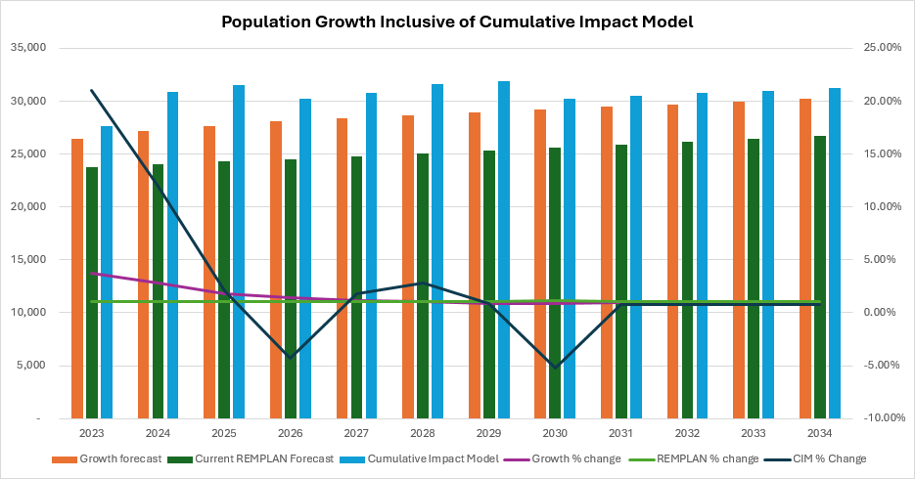

The base case scenario results in a positive operating surplus, sound capacity to meet short-term financial obligations, an improving trend in rates coverage and ability to generate sufficient cash to cover debt payments.

Higher growth will allow for additional rates and airport revenues while the increasing demand will put pressure on facilities and services to meet the rapid population increase. Lower growth will allow for slower implementation of services and upgrades of facilities however will result in less revenue to expand.

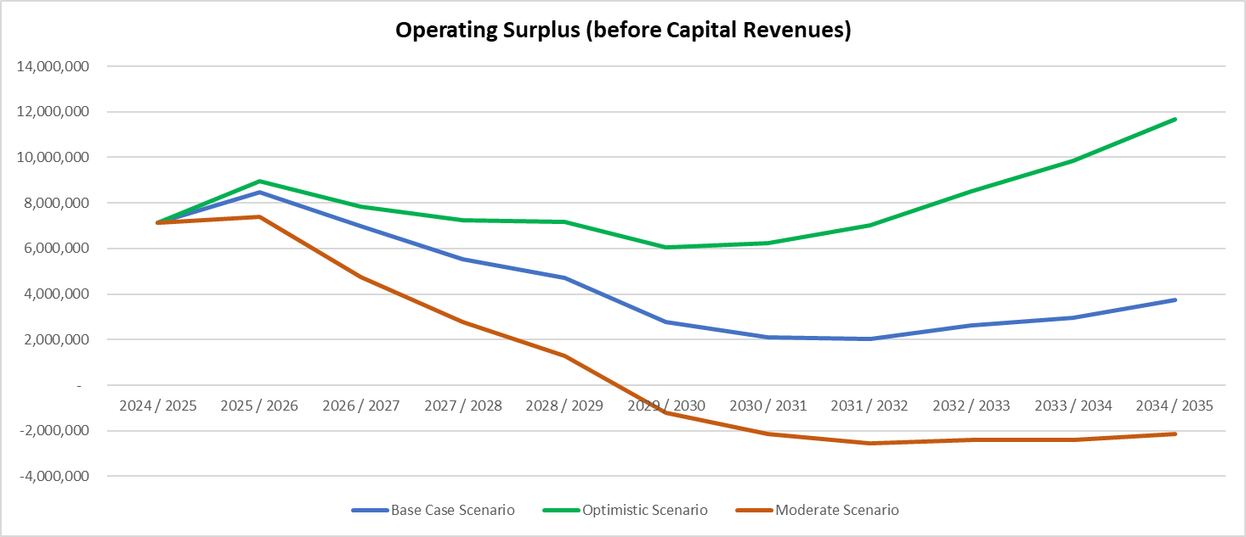

As per the graph, illustrating the operating surplus, by adopting the base case scenario as the foundation for our LTFP, we are able to make financially sustainable decisions, while continuing to seek additional revenue sources, to improve the standard of infrastructure and services available to the community.

The most sensitive criterion in the adopted model is a variation in the level of proposed rate increases. A 1% decrease in the proposed rate assumptions over the ten years of the LTFP results in $29.7 million movement in revenue. Current ratio calculations would be less than the target of 1 from 2028/2029 which measures the City’s ability to meet its short-term financial obligations. The cash short fall would result in additional borrowings required to deliver services and assets to the community.

Airport fees and charges are a significant and a complimentary revenue source to rates revenue. Should council wish to alter its growth assumption, for every 1% variation the likely impact is approximately $15 million in the 10 year plan.

In 2017, Council purchased The Quarter HQ, an investment property operated on a commercial basis to supplement and support the City’s revenue sources. For a change in the assumptions of 1% occur, the resulting impact is approximately $5 million over the ten year period of the long term financial plan.

# Measuring Sustainability

The City of Karratha’s financial sustainability is measured by its ability to fund ongoing service delivery and the renewal and replacement of assets without imposing excessive debt or rate increases on future generations.

The following Key Performance Indicators (KPI) have been prescribed in the *Local Government (Financial Management) Regulations 1996* to measure the financial sustainability of local governments. The City’s LTFP 2024-34 has been assessed against these KPI’s and are outlined below.

## Key Performance Indicators

Own Source Revenue Coverage Ratio

Indication - A measure of a local government's ability to cover its costs through its own revenue efforts.

Target - Intermediate 60% - 90%, Advanced >90%

Commentary - The advanced target of greater than 90% is achieved over the 20 year period. Revenue derived from the City’s operations can cover the City’s operational costs.

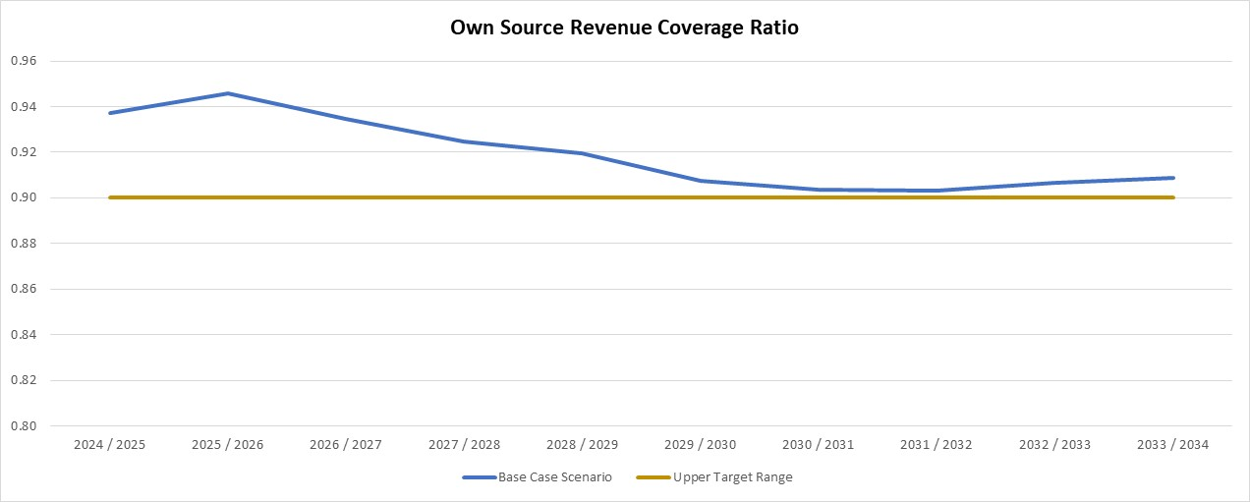

Operating Surplus Ratio

Indication - An indicator of the extent to which revenue raised not only covers operational expenses, but also provides for capital funding.

Target – Between 0% and 15%

Commentary - The target of an operating surplus is achieved each year of the LTFP. This indicates that surplus operational funds are available for capital works.

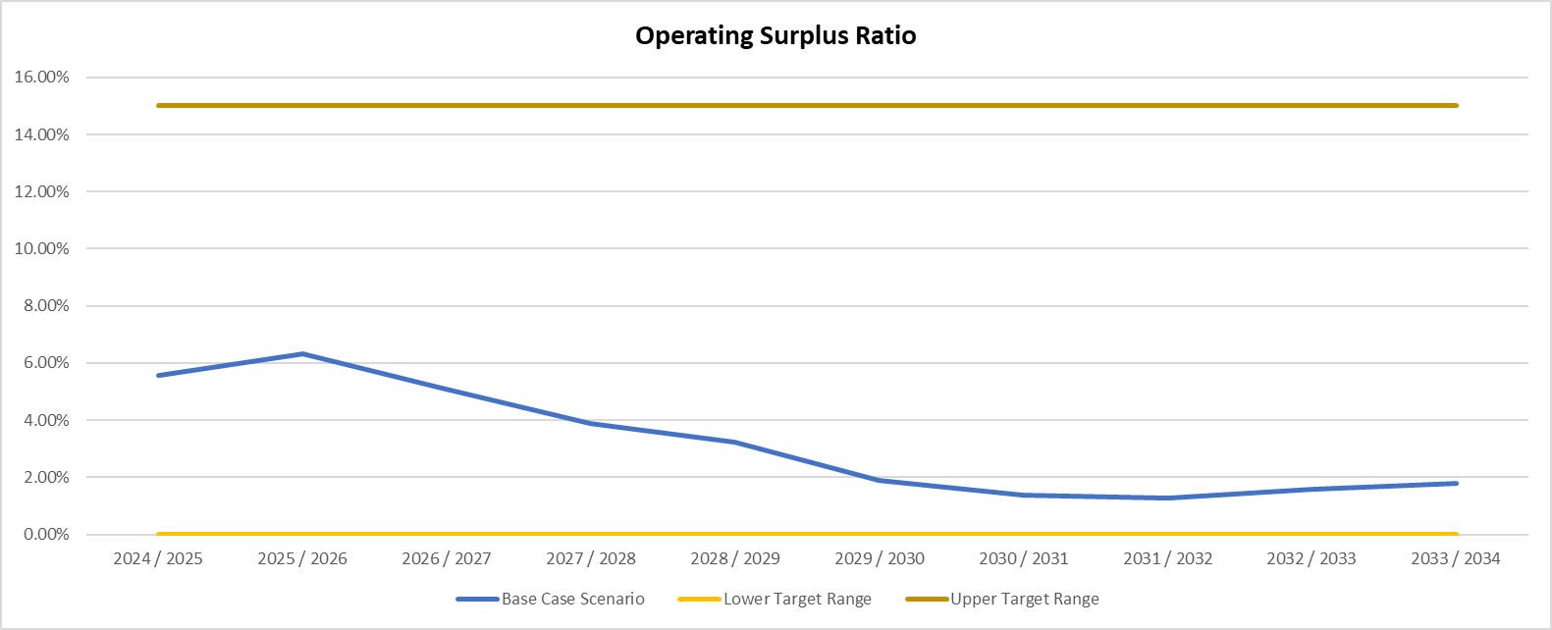

Rates Coverage

Indication - An indicator of a local government's ability to cover its costs through its own revenue efforts.

Target – Greater than or equal to 40%

Commentary - Trend shows the rates coverage ratio being maintained between 40.7% and 41.6%. This indicates the City’s rating strategy allows the town to raise an acceptable level of funds from its rates base.

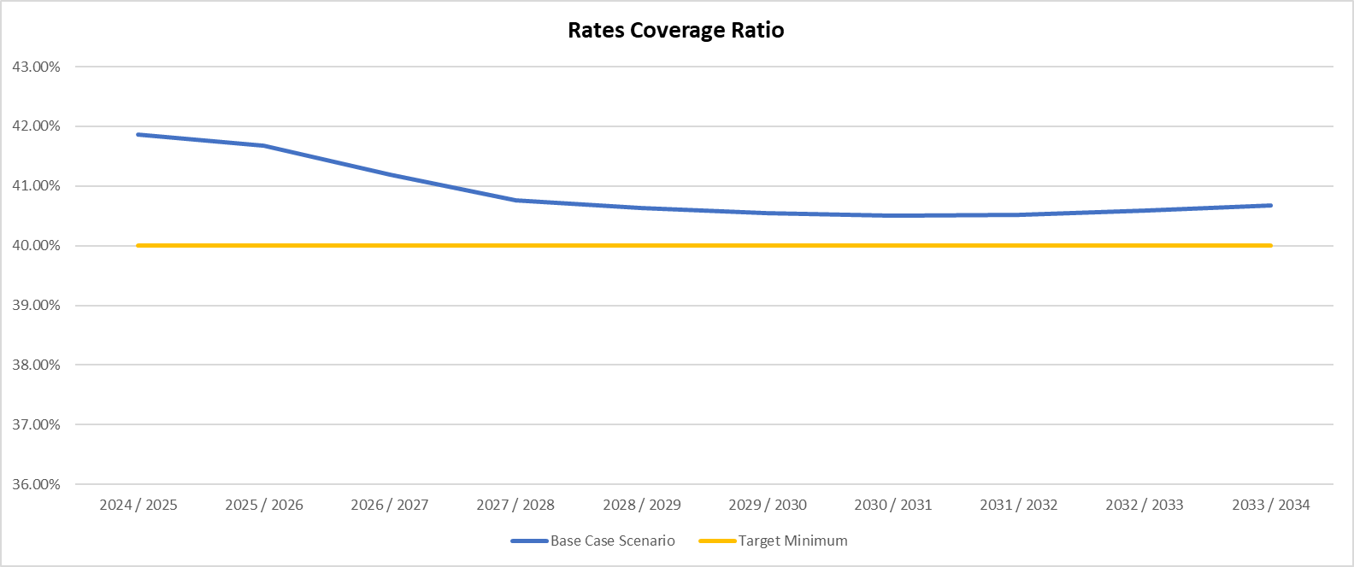

Current Ratio

Indication - A measure of a local government's liquidity and its ability to meet its short term financial obligations from unrestricted current assets.

Target – Great than or equal to 1

Commentary - The target of greater than 1 is maintained throughout the Long Term Financial Plan.

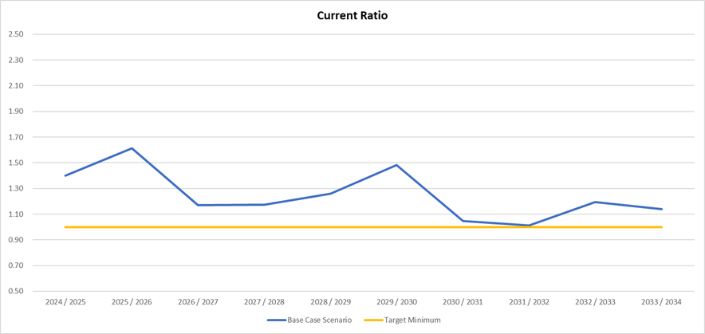

Debt Service Cover Ratio

Indication - An indicator of a local government's ability to generate sufficient cash to cover its debt payment.

Target – Greater than or equal to 2

Commentary - The City’s debt ratio being higher than 2 indicates the ability to fund the proposed levels of debt and in 2036/37 is anticipated to have no outstanding debt.

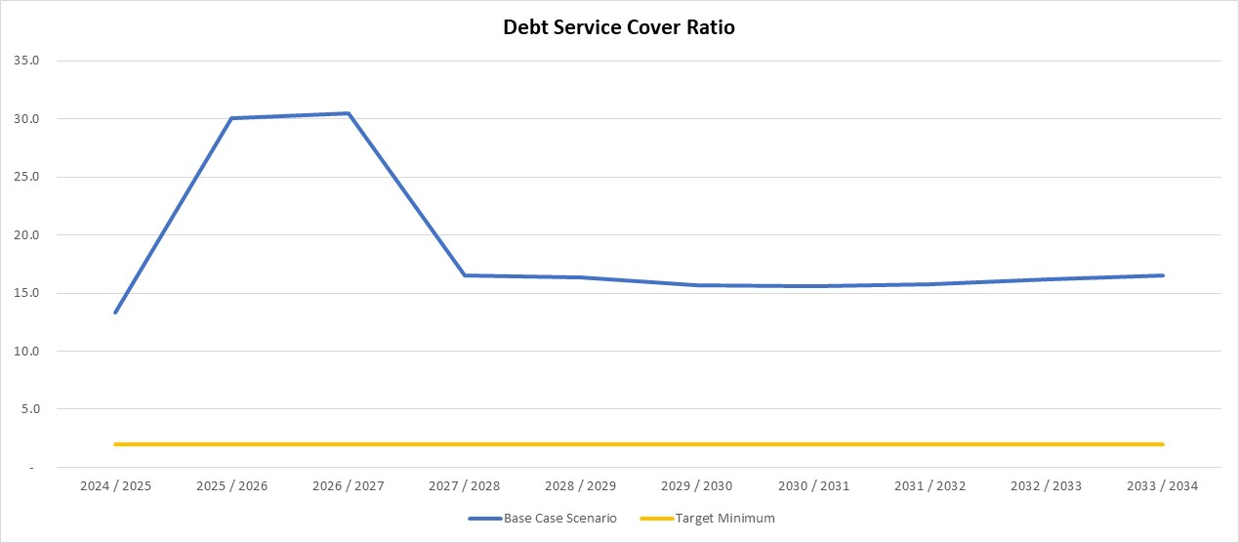

Asset Sustainability Ratio

Indication - An indicator of the extent to which assets managed by a local government are being renewed or replaced as they reach the end of their useful lives.

Target – Between 90% and 100%

Commentary - The City does not expect to achieve a ratio within the target range in 28/29, due to the increase in new asset spend which includes the Roebourne Recreation Precinct., the Windy Ridge Sporting Precinct and Dampier Masterplan, and the Karratha Airport runway upgrade. The ratio begins the return back to asset renewals thereafter, moving downwards again in 2031/32 due to additional new asset spend for the Karratha Airport taxiway extension. It is anticipated that future revisions of the LTFP will identify further asset renewal requirements, which will alleviate the downward trend as new capital works are planned and approved in the future.

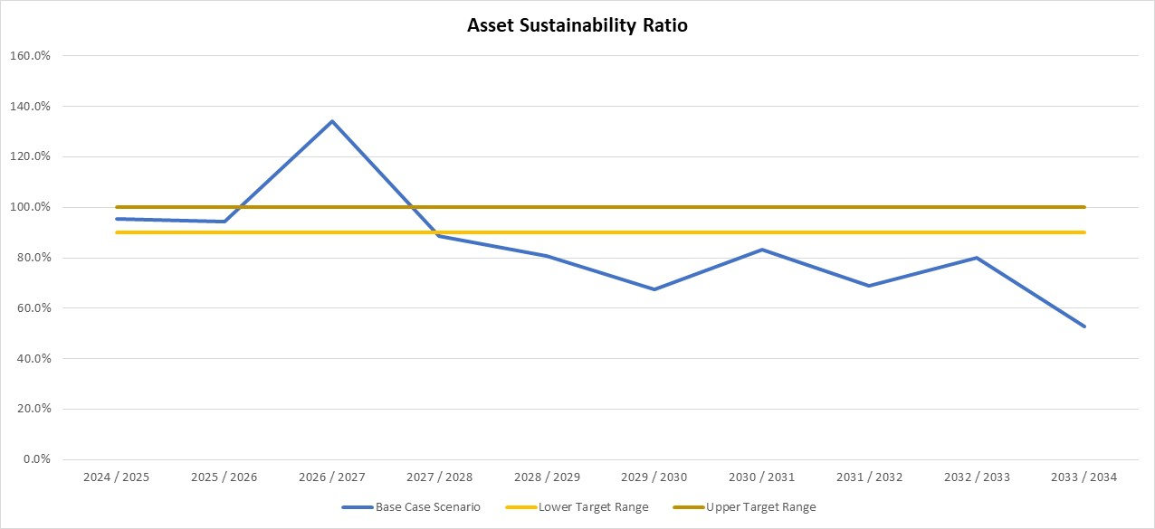

Asset Consumption Ratio

Indication - Highlights the aged condition of a local government's physical assets.

Target – Between 50% and 75%

Commentary - This ratio measures the extent to which depreciable assets have been consumed by comparing their written down value to their replacement value. The City’s ratio is achieved and maintained within the target band over the life of the LTFP.

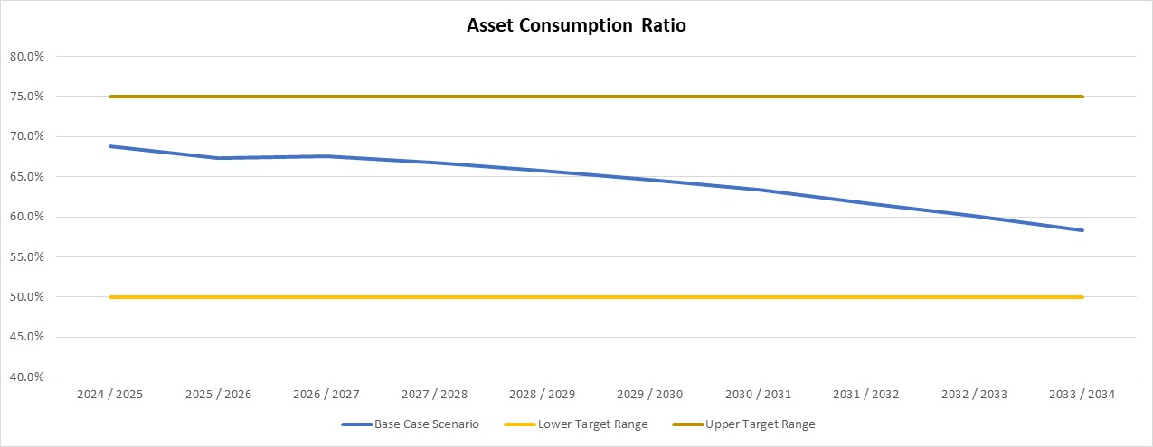

Financial Health Indicator (FHI)

Indication - The Financial Health Indicator is a measurement of a local government’s overall financial health.

Target – Greater than or equal to 70

Commentary - The City is forecast to be in good financial health.

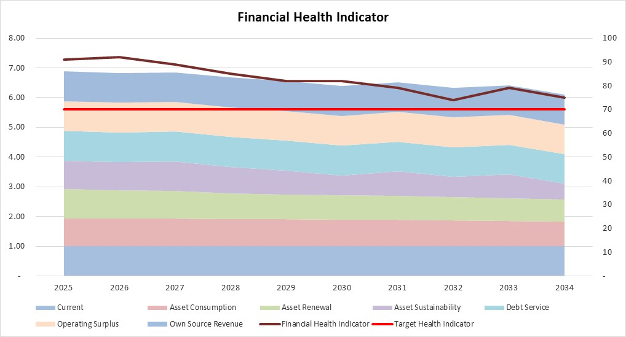

# Key Assumptions underpinning our LTFP

## Operational Revenue and Expenditure

The City’s Long Term Financial Plan projections are based on a number of assumptions regarding Council’s operational revenue and expenditure. The first five years of our LTFP contain a high level of accuracy, however, the capacity to accurately predict Council’s financial position for the remaining period is diminished and includes reasonable estimates only.

The key assumptions are detailed in the table below.

|  |  |
| --- | --- |
| Base Case Key Assumptions | |
| Rates revenue | The LTFP is based on a residential increase of 3.5% over twenty years rates incorporating Madigan, Baynton West, Gregory and Hancock Way, supplemented by additional rates revenue from commercial, plus an annual increase of 2.5%-6.65% based on Consumer Price Index forecast. Conservative estimates for property growth have been utilised pending resource and industry project announcements. |
| Other fees and charges | 2.5%-5.2% increase per year to reflect projected Consumer Price Index (CPI). |
| Airport fees and charges | Recovery from COVID-19 has been quick. Current projects and construction activity in Karratha will drive higher revenues between 2024 - 2028 with a tapering off effect after that. Passenger numbers will also rise with the additional activity increasing revenue. |
| Grants and contributions | CPI used as an indicator to forecast Operating Grants and Contributions.  Roads to Recovery funding will continue into 2024-25. |
| Employee costs | Slight increase in staff levels in 2024/25 as per the Workforce Plan and forecasted growth.  4% growth rate as per the City of Karratha Industrial Agreement 2023 in effect August 2023 with (10%) vacancy rate and 0.5% skill step movement. |
| Materials and contracts | CPI increase for maintenance and operation of existing services and infrastructure. Rawlinsons Building Price Index (BPI) for the Pilbara region has been included to recognize the increased cost of goods and services in the area. |
| % of OPEX on new capital | Assumption that 7.5% of major and 2.5% of minor cost of new infrastructure will be incurred in maintenance and operating costs. |
| Insurance | 2.5%-5.2% increase per year to reflect projected CPI. |

## Economic Assumptions

The following economic drivers have been used to develop this plan:

|  |  |
| --- | --- |
| Economic Assumptions | |
| Consumer Price Index Australia (CPI)  *RBA, Forecast table - June 2025* | 2.50% - 5.20% |
| Western Australian Treasury Corporation (WATC) fixed rate semi-annual interest rate  *WATC Indicative Local Government Interest Rates, August 2024* | 4.06% - 4.93% |
| Term Deposit interest rates | 3.95% - 5.31% |
| Western Australia Local Government (WALGA) Local Government Cost Index  *WALGA Economic Briefing, June 2024* | 2.80% - 4.40% |
| Rawlinsons Regional Indices Western Australia  *Rawlinsons 2023 Edition 41* | 55.0% |
| Regional Price Index (RPI)  *Department of Primary Industries and Regional Development 2023* | 11.1% |

## Capital Works Program

Delivering major infrastructure projects to provide long-term benefits to our community for generations to come is the key focus for the City of Karratha as we continue our transformation into Australia’s most liveable regional city. The creation of new assets and renewal or upgrade of existing infrastructure have been included in developing the LTFP.

This plan outlines a capital works program of $575 million over the 10 year period, which will require borrowings of $16 million to achieve this program.

Capital Works by Program and Schedule

The following graph illustrates capital expenditure by program for the period of the LTFP 2024-2034. The table outlines the capital expenditure by Schedule, the method developed by the City to categorise its Capital Works.

Due to the remote location and large geographical size of the City, transport is a key priority which is demonstrated at 58% of total capital expenditure. Contained within the transport program, Karratha Airport is the City’s largest asset and provides a significant revenue stream. It is essential to the City’s capital portfolio accounting for $76 million in the 10 year Capital Program. Roads, footpaths and kerbing infrastructure are another priority with $50 million of capital expenditure.

Recreation and Culture and Community Amenities are the next greatest capital expenditures, representing a combined 33% of the capital works expenditure over the next ten years. Community feedback resulted in improved sporting and recreation facilities and townsite aesthetics.

As per the 2023 Community Survey, the results, also highlighted housing affordability and availability were regarded as high importance when living in the City of Karratha. Therefore, the City recognises the value of significant expenditure dedicated to new housing initiatives, expected to be $21 million over the next ten years. This estimate does not include the anticipated expenditure likely to arise from ‘Project Dorothy’, as the initiative is still passing through the formal expression of interest process at the time of adopting this iteration of the LTFP.

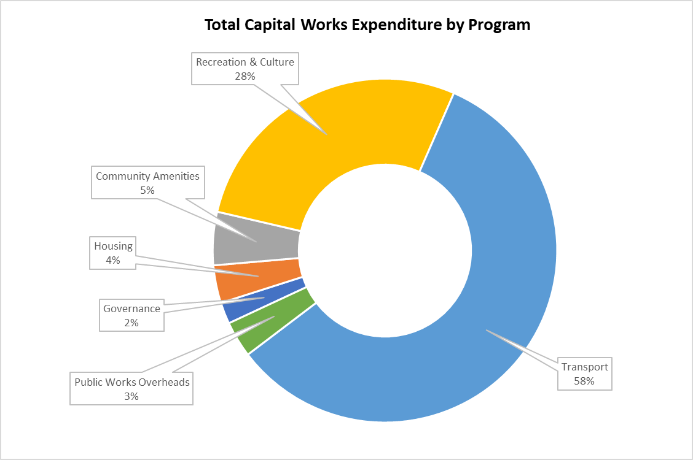

|  |  |
| --- | --- |
| **Total Capital Works Expenditure by Schedule** | |
| Airport | 76,057,419 |
| Townsite Aesthetics | 24,911,400 |
| Community Facilities | 25,127,144 |
| City Offices and Admin Buildings | 7,925,000 |
| City Owned Housing | 25,279,265 |
| Fleet, Plant & Equipment Replacement | 30,302,166 |
| ICT Asset Replacement Program | 10,210,612 |
| Investments | 14,546,755 |
| Karratha Leisureplex | 23,205,592 |
| Campgrounds, Foreshores, Jetties, Parks & Public Toilets | 20,615,379 |
| Red Earth Arts Precinct | 10,605,947 |
| Drainage & Reuse Schemes | 7,985,000 |
| Roads, Footpaths and Kerbing | 50,315,404 |
| Sporting & Recreation | 78,367,609 |
| Waste Facility | 15,608,426 |
| Total Capex by Schedule | 421,063,118 |

## Housing Initiatives

The City is currently experiencing a shortage of properties to buy and/or rent and future resource sector growth is expected to intensify this issue. Without a rapid development of additional dwelling stock, it is likely that there will be a spike in house and rental prices. Given this situation, the City is proposing a Housing Investment Program to alleviate this problem.

The housing program, referred to as Project Dorothy, includes the following initiatives:

* Service Worker Accommodation (SWA)
* Hancock Way Development
* Warrier Street Refurbishment
* Agreements with external parties to develop and expand housing
* Walgu Housing Development

## Exclusions

Prospective projects and facilities that are not sufficiently detailed at this stage, have not been included in the plan. They will be incorporated into future plans once transparency around timing, revenue, expenditure and capital are known.

At this time of economic uncertainty, costs will continue to change. Therefore, it is necessary to effectively draw a line in the sand when preparing the capital program for the LTFP. The values disclosed in this plan represent estimated future prices and costs and will be reviewed regularly.

# Key Risks to Long Term Sustainability

The LTFP has identified the below key risks that present substantial challenges for the City of Karratha’s long term sustainability given the current and future demands anticipated for facilities and services.

|  |  |
| --- | --- |
| Key risks | Challenge |
| Population uncertainty | Population growth forecasts vary significantly, making it difficult to calculate market demand for facilities and services in our long term financial planning. |
| Dispersed population | Population spread across five distinct towns, requires duplication of facilities and services in each town, creating financial pressure. |
| Resource expansion | Resource projects’ State Agreements create inequity in our rating process across business and industry and severely limit our ability to source additional capital and operational funding to offset Fly-In, Fly-Out (FIFO) impacts on community facilities and services. |
| Cost pressure increase | Local government costs continually increase at a higher rate than CPI, with additional costs associated with the remoteness of the Pilbara compounding the issue. |
| Reduction in State and Federal Government grants | Grants and contributions are received from State and Federal Governments based on their population and capacity to generate rates and revenues. As the City progresses, it is anticipated that grants and contributions from Governments will decrease. |
| Cost shifting from other levels of government | The City’s service delivery requirements are beyond typical local government responsibility due to our remote location. These services include a range of community, health, environmental and planning services, tourism, heritage, entertainment and so forth, with funding that does not always account for substantial distances to service localities and higher costs associated with being in the Pilbara. |
| Organisational capacity | Attracting and retaining staff with requisite skills is a constant challenge due to remoteness, cost of living, housing affordability and salary competition from the resource sector. |
| Asset management planning | The ability to accurately quantify the financial risks over a long period is difficult as the Asset Management Plan is a five year plan. |

To address these risks, the Long Term Financial Plan is reviewed and updated regularly.

# Financial Projections

Our financial projections for the LTFP conform to the *Local Government (Financial Management) Regulations 1996* and Australian Accounting Standards.

We have followed a format within our LTFP that allows our projections to feed into the statutory format of our Annual Budgets, as well as allowing the key performance measures outlined in our LTFP to be compared with our Annual Budgets and Annual Reports.

## Financial Statements

The financial statements as per Appendix A, have been prepared for the 10 years covered in the LTFP. These estimates have been prepared on the basis of the assumptions shown previously in the document.

Our statutory statements include:

* Statement of Comprehensive Income by Nature
* Statement of Cash Flows
* Statement of Financial Activity
* Statement of Financial Position
* Statement of Changes in Equity

Statement of Comprehensive Income by Nature

Identifies the cost of goods and services provided, and the extent to which costs are recovered from revenues. A surplus is estimated for each year of the LTFP.

Statement of Cash Flows

The purpose of this statement is to show how changes in balance sheet accounts and income affect cash and cash equivalents, breaking the analysis down to operating, investing and financing activities. Net cash provided by operating activities illustrates how much cash is expected to remain after funding the services provided to the community. This can be used to fund other activities such as infrastructure and capital works. Information provided by the Statement of Cash Flows can assist in recognising the ability to generate cash and meet financial commitments, including repayments of debt.

Statement of Financial Activities

This statement, formerly known as the Rate Setting Statement, summarises the operating, capital, debt and reserve transactions. The plan identifies the funds necessary to balance the budget in each financial year through the collection of rates. The format of the Statement of Financial Activity in the LTFP varies from the Annual Budget. The Annual Budgets bottom line represents the amount required from rates. In the LTFP, rates are assessed in accordance with relevant assumptions to the plan. If a surplus results, this can be used to fund other services however, where a shortfall results this indicates that the Council is unable to fund the services proposed at the planned rating levels. The LTFP shows a budget deficit, however the new borrowings included in the plan will cover the cost of planned service requirements within the LTFP.

Statement of Financial Position

This statement summarises the expected financial position of the City at the end of the financial year. It reports what is expected to be owned (assets) and what is expected to be owed (liabilities). The statement discloses transactions as current and non-current assets, and current and non-current liabilities (net assets) and equity.

Statement of Equity

The purpose of this statement is to report the changes in equity over an accounting period. The LTFP uses this to show the changes in accumulated funds and reserves over the next 10 years.

These statements are supported by our following schedules:

* Ten Year Capital Works Program
* Loan Repayment Schedule
* Cash Reserves
* Sustainability Ratios

# Implementation and Review of the Long Term Financial Plan

Council considers the content of our long term financial plans when preparing the City of Karratha’s Annual Budget.

Since the creation of our first long term financial plan in 2012, adopted Annual Budgets have been aligned with the proposals made in the plan and the underlying assumptions.

We have conducted reviews of the LTFP each year as part of our Operational Plan and Annual Budget development to account for performance information and any changing circumstances.

Council is confident the modelling in the LTFP provides clear guidance on the financial impacts of various activities, initiatives, service levels and programs, allowing the City to set priorities within its resourcing capabilities, to sustainably deliver the infrastructure and services our community needs.

# Appendices

## Appendix A - Financial Statements

Statement of Comprehensive Income by Nature

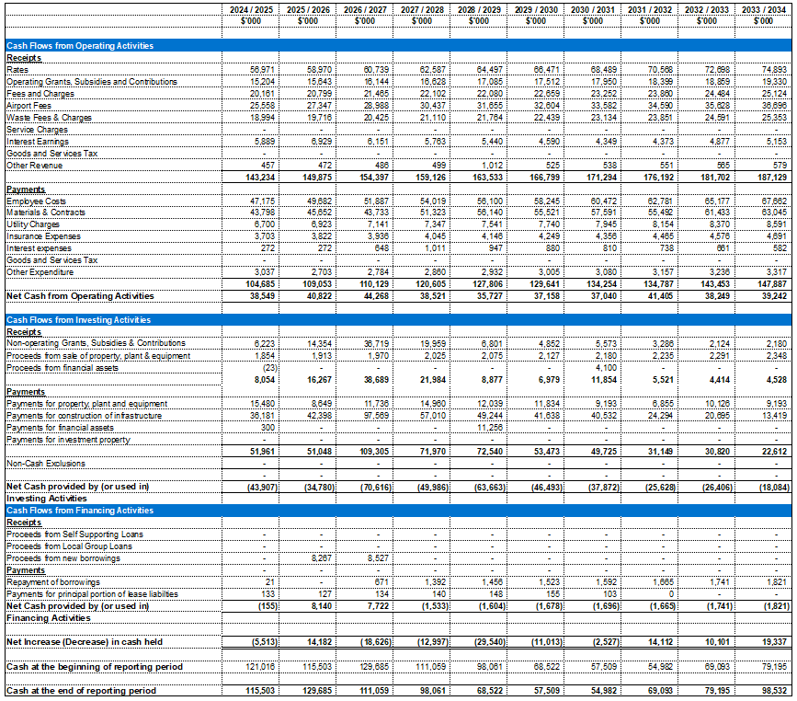Statement of Cash Flows

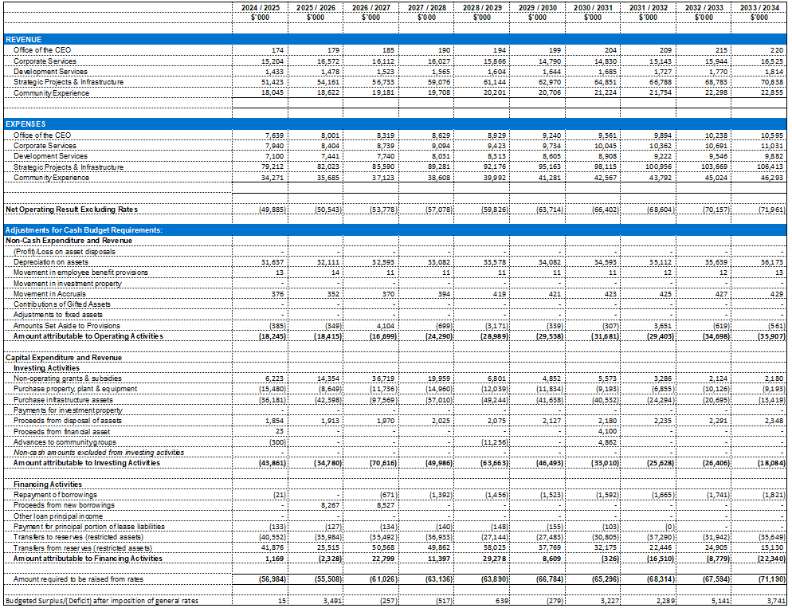Statement of Financial Activity

Statement of Financial Position

Statement of Changes in Equity

## Appendix B – Supporting Schedules

Ten Year Capital Works Program

Loan Repayment Schedule

Cash reserves

Sustainability Ratios

## Appendix C - Important Documents and Policies

This document should be read in conjunction with the following City documents:

* Council Policy CF-03 Investment Policy
* Council Policy CF-10 Rating Equity Policy
* Council Policy CF-13 Asset Management Policy
* Council Policy CF-14 Reserve Funding Policy
* Council Policy CF-16 Budget Review Policy
* Council Policy CG-01 Risk Management Policy
* Strategic Community Plan
* Corporate Business Plan
* Asset Management Plan
* Annual Budget
* Workforce Plan
* Integrated Strategic Plan

## Appendix D - Glossary

| Term | Definition |
| --- | --- |
| Annual Budget | A statutory requirement outlining the financial estimates to deliver the Corporate Business Plan. |
| Annual operating surplus | Operating revenue minus net operating expense before interest and depreciation. |
| Asset Management Plans | Plans that guide the use, acquisition and disposal of assets to make the most beneficial use of their services delivery potential and to manage related risks and costs over their entire life. |
| Asset consumption ratio (ACR) | The Asset Consumption Ratio seeks to highlight the aged condition of a local government's stock of physical assets. The ratio can be calculated by dividing the depreciated replacement cost of assets by the current replacement cost. Standard is met if the ratio can be measured and is 50% or greater, the standard is improving if the ratio is between 60% and 75%. |
| Asset renewal funding ratio | Means the ratio determined by depreciated replacement cost of assets divided by current replacement cost of depreciable assets. |
| Asset sustainability ratio | Means the ratio determined by capital renewal and replacement expenditure divided by depreciation expense. |
| Capital funding | Funding available to pay for capital expenditure. |
| Capital grants/contributions | Monies received generally tied to the specific projects for which they are granted, which are often upgrade and/or expansion or new investment proposals. |
| Capital new expenditure | Capital expenditure that creates a new asset providing a new service to the community that did not exist beforehand. As it increases service potential it may impact revenue and will increase future operating and maintenance expenditure. |
| Capital renewal expenditure | Capital expenditure on an existing asset that returns the service potential or the life of the asset, up to, that which it had originally. It is periodically required expenditure, relatively large (material) in value compared with the value of the components of the asset being renewed. As it reinstates existing service potential, it has no impact on revenue, but may reduce future operating and maintenance expenditure if completed at the optimum time. Where capital projects involve a combination of renewal, expansion and/or upgrade expenditures, the total project costs need to be allocated accordingly. |
| Capital upgrade expenditure | Expenditure, which enhances an existing asset to provide a higher level of service, and expenditure that will increase the life of the asset beyond that which it had originally. Upgrade expenditure is discretional and often does not result in additional revenue unless direct user charges apply. It will increase operating and maintenance expenditure in the future because of the increase in the council’s asset base. Where capital projects involve a combination of renewal, expansion and/or upgrade expenditures, the total project costs need to be allocated accordingly. |
| Corporate Business Plan | A local government’s internal business planning tool that translates Council priorities into operations, within the resources available. The Corporate Business Plan details the services, operations and projects a local government will deliver over a defined period. |
| Current ratio | This is a modified commercial ratio designed to focus on the liquidity position of a local government that has arisen from past year's transactions.  (Current Assets MINUS Restricted Assets) divided by (Current Liabilities MINUS Liabilities Associated with Restricted Assets) |
| Depreciation/amortisation | The systematic allocation of the depreciable amount (service potential) of an asset over its useful life. |
| Infrastructure assets | Physical assets of the entity or of another entity that contribute to meeting the public’s need for access to major economic and social facilities and services, e.g. roads, drainage, footpaths and shared paths. These are typically large, interconnected networks or portfolios of composite assets. The components of these assets may be separately maintained, renewed or replaced individually so that the required level and standard of service from the network of assets is continuously sustained. Generally, the components and hence the assets have long lives. They are fixed in place and often have no market value. |
| Integrated Planning and Reporting | A framework for establishing community priorities and linking these to different areas of a local government’s functions. |
| Level of service | The defined service quality for a particular service against which service performance may be measured. Service levels usually relate to quality, quantity, reliability, responsiveness, environmental, acceptability and cost. |
| Liquidity ratio | Liquidity refers to how quickly and cheaply an asset can be converted into cash. A local government's liquidity is measured by the 'Current Ratio'. This ratio provides information on the ability of a local government to meet its short-term financial obligations out of unrestricted current assets. |
| Loans / borrowings | Loans result in funds being received which are then repaid over a period of time with interest (an additional cost). Their primary benefit is in ‘spreading the burden’ of capital expenditure over time. Although loans enable works to be completed sooner, they are only ultimately cost effective where the capital works funded (generally renewals) result in operating and maintenance cost savings, which are greater than the cost of the loan (interest and charges). |
| Operating expenditure | Recurrent expenditure continuously required to enable the asset to operate excluding maintenance and depreciation, e.g. electricity, water and fuel. It relates to operations and not the condition of the asset. |
| Operating revenue | Means the revenue that is operating revenue for the purposes of the Australian Accounting Standards, excluding grants and contributions for the development or acquisition of assets. |
| Risk management | The application of a formal process to the range of possible values relating to key factors associated with a risk in order to determine the resultant ranges of outcomes and their probability of occurrence. |
| Scenario modelling | Preparation of forecast or estimates in the LTFP on optimistic, conservative and worse case scenarios to understand the impact of variations in factors or assumptions. |
| Sensitivity analysis | Determines those factors or assumptions that if varied have greater impacts on the LTFP. |
| Strategic Community Plan | The strategy and planning document that reflects the longer term (10+ years) community and local government aspirations and priorities. |
| Workforce Plan | A coordinated plan that addresses the human resourcing requirements to deliver local government operations. |