

STREETSCAPE DESIGN GUIDELINES
Document Control Statement –This Standard is maintained by the City of Karratha Engineering Services team. Any printed copy may not be up to date, and you are advised to check the electronic copy at the City of Karratha Website to ensure that you have the current version. Alternatively, you may contact Customer Service on (08) 9186 8555.

SCOPE

Purpose
Streetscapes refer to the overall visual appearance and character of a street, road, or public open space. This guideline provides general requirements for street furniture, lighting, signage, and other elements that contribute to the look, feel, and functionality of pedestrian areas in the City.
Prior to starting work, a Before You Dig Australia inquiry should be completed to determine the locations of any existing services. If works are part of a new development on previously uncleared land a review of native vegetation should be completed, and native vegetation kept where possible.

Applicable Standards
The installation, materials and workmanship shall comply with all relevant current Australian Standards, Codes and Regulations and all reference codes and Standards listed in the prefaces to those standards and codes.
Where Australian Standards and Codes do not exist the appropriate International Standard or Codes shall apply. Request an instruction from the City for amendments to Standards, Codes or Regulations that come into effect during the works and affect the works of the contract.
Document | Title
AS 1100 Suite | Drawing Practice
AS/NZS 1158 Suite | Lighting for roads and public spaces
AS 1172 Suite | Sanitary plumbing products
AS 1428 Suite | Design for access and mobility
AS/NZS 1163 | Cold-formed Steel Hollow Sections
AS/NZS 1680 | Interior Lighting – Safe Movement
AS 2008 | Bitumen for pavements
AS 2082 | Timber – hardwood – visually stress-graded for structural purposes
AS 2150 | Asphalt – a guide to good practice
AS 2890.3 | Parking facilities – Bicycle facilities
AS/NZS 3500.1 | Plumbing and drainage – Water services
AS/NZS 3500.2 | Plumbing and drainage – Sanitary plumbing and drainage
AS/NZS 3678 | Structural steel - Hot-rolled plates, floorplates and slabs
AS/NZS 3679 Suite | Structural steel - Hot-rolled bars and sections
AS 23907 | Sharps injury protection - Requirements and test methods - Sharps containers (ISO 23907-2:2019, MOD)
AS 4086.1 | Secondary batteries for use with stand-alone power systems
AS 4422 | Playground surfacing – specifications, requirements and test methods
AS 4685 Suite | Playground equipment
AS/NZS 4455.1 | Masonry units, pavers, flags and segmental retaining wall units
AS/NZS 4600 | Cold-formed steel structures
AS/NZS 5139 | Electrical installations - Safety of battery systems for use with power conversion equipment
AS 60529 | Degrees of protection provided by enclosures (IP Code)
CKS-100 | City Concrete Specifications
CKS-700 | City Landscape Specification
CKS-900 | City Subdivision Guidelines
City Strategy | City Playground Strategy 2023
IPWEA LGGSD | Institute of Public Works Engineering Australasia – Local Government Guidelines for Subdivision Development
MRWA LDGRPS | MRWA Lighting Design Guideline for Roadway and Public Spaces
MRWA 1830-0002 to 0005, 0013 to 0015 | MRWA Drawings for standard signposts.

PUBLIC OPEN SPACES

General
Developers are required to submit a landscape plan for approval to develop public open spaces. Public open spaces and infrastructure should be designed to be accessible in accordance with the AS 1428 series.
Public open spaces shall be designed to enable passive surveillance by residents to:
- Minimise potential for crime and vandalism
- Ensure the safety of children, especially near play equipment
Public open spaces must take into consideration Crime Prevention through Environmental Design (CPTED) principles and apply them to new and renovation projects.
The developer shall allow for adequate power connection requirements for the full lifecycle of the public space.
Plantings shall comply with the City’s Landscape specifications CKS-700. Drawings and specifications shall include a schedule stating the type, species, number, and size of the pot, seeds, trees, shrubs, ground covers, herbs, and grasses to be planted. The plan shall show the location and density of planting. Specifications shall show details on how the plants are planted, fertilised and protected.
All street furniture shall be a minimum of 1000mm clear of an accessible path of travel.

Design Plans
Design plans shall show the following details (in accordance with IPWEA LGGSD):
- Cadastral boundaries of the site
- Existing services
- Survey marks
- Fences
- Significant vegetation and trees
- Existing and proposed contours
- Existing or proposed buildings
- Proposed access roads and parking areas
- Pedestrian and cyclist facilities
- Disabled access facilities
- Existing or proposed stormwater or drainage management facilities
- Playground equipment
- Proposed irrigation system
- Other features pertinent to the development of the public open space
- Areas and details of native vegetation proposed to be removed
- Street furniture

Public Toilets
Public toilets should be located on a continuous accessible path of travel from other accessible facilities in the area, such as car parks, picnic areas and shops. Developers shall submit toilet facility designs for the City’s approval as required.

FURNITURE

Park Bench Seating
Park benches shall comply with the dimensional requirements in AS 1428.2 Clause 27.2. All benches shall be chemically anchored to a concrete footing and not cast-in concrete to enable future relocation.

Drinking Fountains
Drinking fountains shall be provided in public spaces to aid with hydration and prevent heat stress. The preferred drinking fountain model is the Civiq Aquafil Bold 850BF Drinking fountain & bottle fill stations with swinging dog bowl.

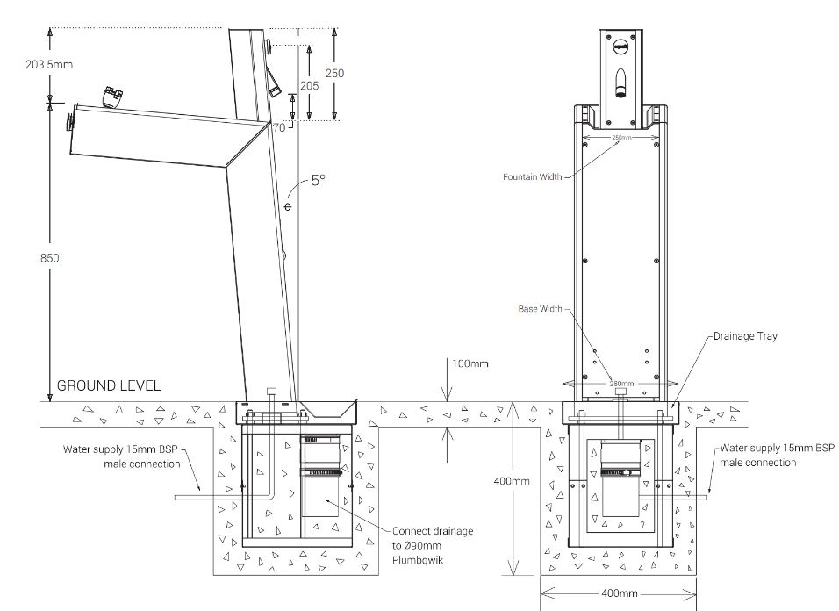
Figure 1: Drinking fountain requirements – Civiq Aquafil Bold 850BF.
An isolation valve shall be designed and installed just upstream of the drinking fountain to enable maintenance. This isolation valve shall be located in an accessible, lockable valve box adjacent to the drinking fountain.
Drinking fountains shall comply with AS 1428.2 Clause 27.3; fountains and the water trajectory shall have the minimum access dimensions in AS 1428.2 Figure 33.

Bicycle Facilities
Bicycle parking shall be designed in accordance with AS 2890.3.
Bicycle racks shall be located at least 2250mm clear from buildings and 750mm clear from the face of the roadside kerb in accordance with AS 2890.3 Figure 2.3.
Bicycle racks shall be chemically anchored to a concrete foundation.
Racks must be designed to support the bicycle frame – racks that only support the front wheel of the bicycle shall be avoided in accordance with WALGA P&DBRWA Clause 11.2 to avoid damage to bicycles.
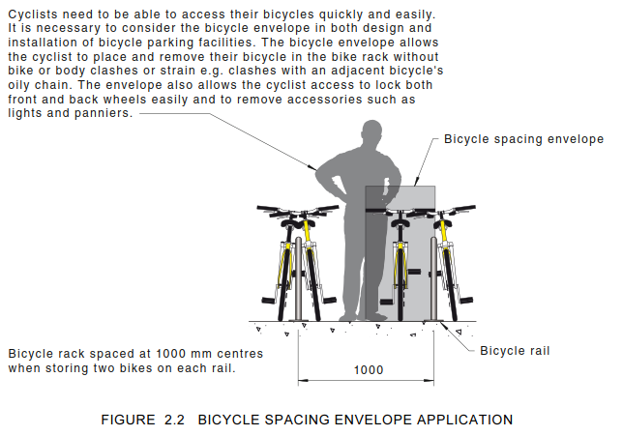
Figure 2: Bicycle rack space envelope - Extract from AS 2890.3 Figure 2.2
Bicycle parking adjacent to roads with a speed limit greater than 60km/h should be protected by a pedestrian barrier in accordance with AS 2890.3.

Play Equipment
All play equipment shall meet the requirements of the AS 4685 series of standards.
All playground equipment with a free fall height greater than 600mm must have an impact attenuation surface complying with AS 4685.1 Clause 4.2.8.5.2 and AS 4422.
Playgrounds shall be appropriately shaded in accordance with AS4685.0 Appendix A.
Playgrounds shall meet the intent of the City’s Playground Strategy 2023.

Irrigation
Irrigation used for public open spaces shall comply with the City’s irrigation specification.
Sprinkler water distribution footprints shall overlap adjacent sprinkler footprints.

Rubbish Bins
Rubbish bin enclosures used in the City shall comply with Table 1 and Figure 3.
Table 1: Preferred Bin Enclosures
 | Bin Item # (Refer to Figure 3)
 | A | B | C
Application | City Centre 240L Bin Enclosure | Park 240L Bin Enclosure | City Centre Round Bin
Model | LR6164 | Allure (Norfolk) | K0279B Custom Litter Receptacle Karratha
Description | Perforated Bin Enclosure | Bin surround | 316SS Bin enclosure with mild steel galvanised inner liner
Required product options | Flat Lid 304SSF  304 Stainless Steel – Satin Polished Body  Square Perforations  No signage required  Locking mechanism | Pressed metal electro-plated and powder coat finish – Citi Pearl  Locking mechanism | 316 Stainless Steel Curved Lid, Body, Frame, Lock and 400mm Chain  Extended leg fixing supplied as a single unit.
Dimensions (mm) | 1090H x 800L x 700W | 1370H x 800L x 800W | N/A
Volume (L) | 240 | 240
Preferred Supplier | MC628 Commercial Systems Australia | ME175 Exteria | MC628 Commercial Systems Australia
Approximate Lead Time | 8 weeks | 5 weeks | 8 weeks
City Stores # | S5630 | S5621 | S5625

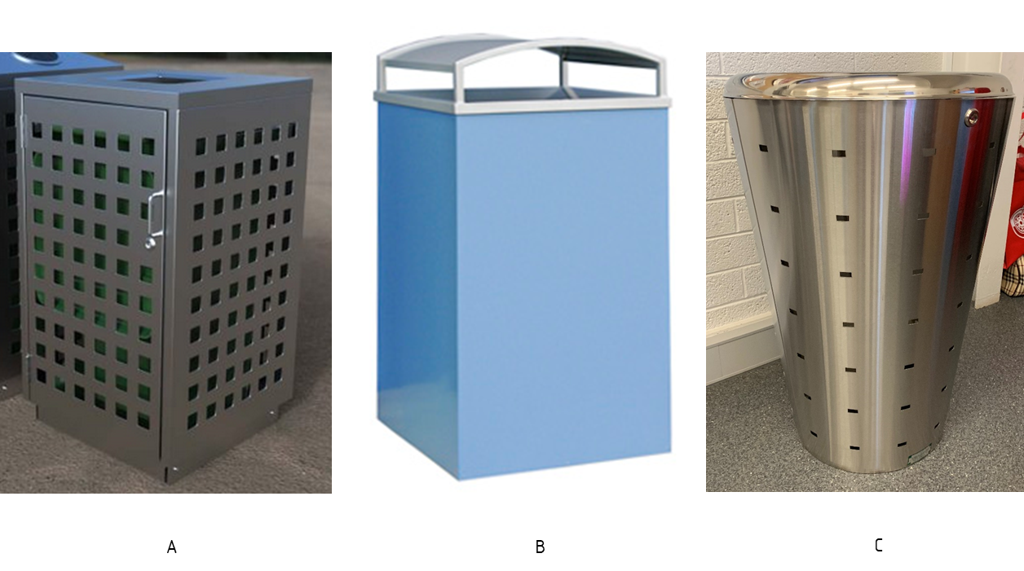
Figure 3: Preferred Bin Enclosures
Bins shall be located in areas allowing for clearance of a full door opening and enabling full access.
Outdoor bins shall be anchored to a concrete slab, minimum 100mm thick, 2m x 2m. The foundation underneath the slab shall be compacted to 95% MMDD, with a minimum of 80mm thick crushed blue metal aggregate.

Street Signage
Signs, signage structures and footings shall be designed for AS 1170 Wind Region D.
Street signs shall be designed to AS 1742.5.
The City requires that street signs be manufactured to the following specifications:
Table 2: Street Sign Requirements
 | Speed Limit <80km/h | Speed Limit >80km/h | Reference
Lettering height (mm) | 100 | 130 | AS 1742.5 Table 2.1
Sign-plate height (mm) | 150 | 200
Sign-plate | Hollow Extrusion
Length | 1000 | 1000 | AS 1742.5 Clause 2.2
Number of posts | 2 | 2
Sided | Double-sided
Background | 3M Class 1 Diamond Grade Reflective Sheeting  Minimum 10-year service life.
Lettering | Series DN or CN
Mounting height | Between 2.5m and 3.0m from ground level to the underside of the sign-plate

- Wording to be centrally located on the sign plate with the abbreviation to be 50mm lettering at the top right-hand side of the street name.
- Anti-graffiti film is to be applied.
- Signs are to be mounted either on two (2) 60 OD posts or onto Horizon Power poles where they are opposite an intersection.
- All brackets are to be supplied with a sign plate.
- Lateral placement on urban roads to be on the 2.7m alignment unless otherwise approved.
- Lateral placement on rural roads to be at least 600 mm clear of the outer edge of the road shoulder.
- Main Roads WA provide standard methods for the size of sign structures:
  - Use MRWA Drawing 1830-0002 to determine wind speed region and terrain category
  - Use MRWA Drawing 1830-0003 to determine sign area and post spacing
  - Use MRWA Drawing 1830-0004 and 1830-0005 to determine the force acting on the sign
  - Use MRWA Drawing 2130-0654 for post-selection
  - Use MRWA Drawings 1830-0013, 1830-0014 and 1830-0015 to determine footing dimensions and reinforcement required
Refer to Figure 4 below for typical street signplate and footing detail.
Street name abbreviations shall be in accordance with Figure 5.
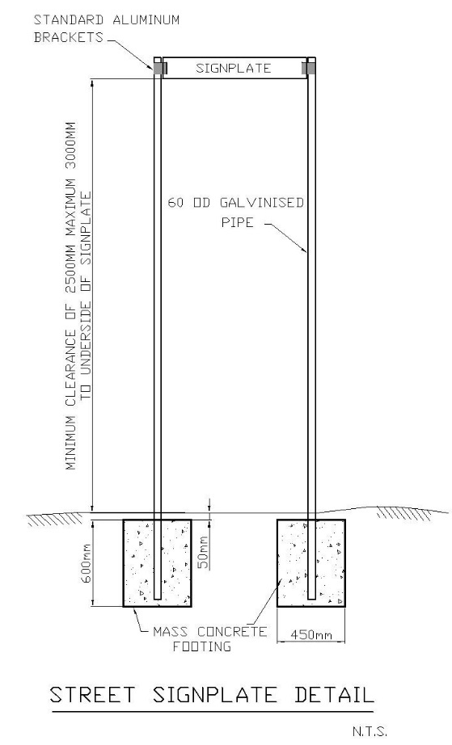
Figure 4: Street Signplate Detail
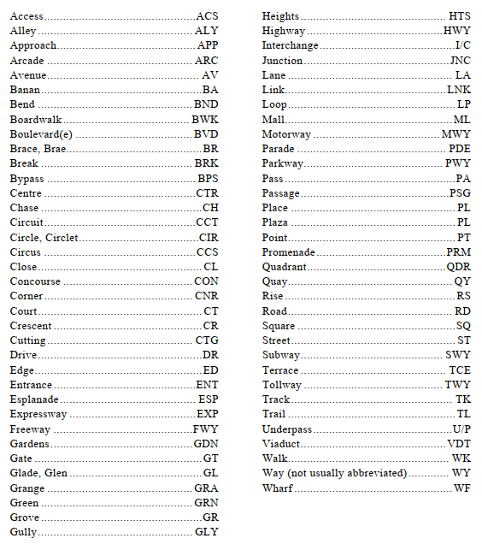
Figure 5: Street Name Abbreviations – Extract from AS2890.3 Appendix D.
Refer to IPWEA Standard Drawing RS-130 “Street Name Sign and Location” for further details.

RESIDENTIAL REQUIREMENTS

Fencing
Residential fencing abutting a public open space shall be visually permeable in accordance with IPWEA LGGSD Clause 6.1.

Verges
Verges shall be designed in accordance with IPWEA LGGSD Clause 3.3.4:
  - Verge grading should fall a minimum of 1:50 from the property boundary to the top of the kerb.
  - In areas of steep grades and accessways, the verge can be graded to suit the natural land contours
  - Verges on the high side of a local distributor road may fall 1:50 towards the road and battered to suit the finished contours at a maximum 1:6 slope.
  - Verge surface to be comprised of compactable material to ensure the material does not wash away. This City’s recommended verge treatment is stabilised gravel with street trees.
  - Minimum verge width 4m.
  - Maximum grade of grassed verge areas 1:6, maximum grade of planted verge areas 1:4.
  - Refer to the Utility Providers Code of Practice for service alignments, including street trees and lights.
  - Refer to the City’s Design Guidelines for Footpath for path alignment.

Cross Overs
Refer to the City’s Crossover Policy and standard drawings.

Paths
Refer to the City’s Footpath Design Guidelines.

STREET LIGHTING
Prior to design and supply, a desktop review of the sites proposed by the City should be undertaken. The purpose of this review is to inform suitable lighting for site and location plan that considers:
- The location of services (BYDA).
- Proximity and potential spill effect on residential properties.
- Footing/pole locations; and
- Achieving uniform lux levels.

Site Lighting And Location Plan
Lighting design to include a site lighting and location plan. This should include the following:
- Exact number of lights required to achieve a P2, PR2, PP2, PA2, PE2 and PC2 lighting category as prescribed in AS/NZS 1158.2 and AS/NZS 1158.3.1.
- Exact location of light poles (and battery pits if required).
- The distance between neighbouring poles.
- Complete lux design nominating anticipated lux level and light spread across the nominated site.
- Light and solar panel orientation.
- Identification of poles that require light shields to mitigate light spillage into residential properties.
- Identification of any areas that may require tree lopping/shrub removal; and
- Identification of any areas that may require rock pitching to support footing installation.

Design Package Requirements
Finished design package to include, but is not limited to, the following:
- AutoCAD drawing specifications and pdf.
- Certificate of Design Compliance and Engineering certification for Region D and Importance Category 2.
- Certified set of design drawings, including shop detail drawings.
- Manufacturer Data Report (MDR).
- Manufacturer Warranty.
- Installation and Operation Manual (IOM).
- Maintenance and Troubleshooting Manual.

Lighting Design Criteria
The following design criteria apply to Solar lighting:
Table 3: Lighting Design Criteria
Criteria | Value | Standard/Reference
Lighting Subcategory | P2 | AS/NZS 1158.3.1
Wind Rating of pole footings, poles, solar panels and luminaires | Region D  Importance Level 2 | AS/NZS 1170.2
Technology | Light Emitting Diode (LED)
Ambient Temperature (minimum requirements) | 0 to 50°C
Required light pole & electronics temperature rating | Minimum 70°C
Relative Humidity (minimum requirements) | 35% to 55%
Direct Normal Solar Irradiation | 28 MJ/m²
Protective Coatings – Minimum Dry Film Thickness | 75µm Zinc Rich Primer  175µm Two-Pack Epoxy  75µm Acrylic polyurethane finish  or  600 µm Hot Dipped Galvanising | AS 2312.1  AS/NZS 4680  AS/NZS 1214
Design Life | 25 years
Ingress Protection Rating | IP10 Indoor  IP65 Outdoor | AS 60529:2004
Impact Rating | IK10 | IEC 62262
Pole Material | Hot Dipped Galvanised Steel or Aluminium
Minimum height | 13.7m | MRWA Lighting Design Guideline for Roadway and Public Spaces
Recommended Dimensions | As per Australian Standard | AS 1798
Hours of Operation | Dusk till Dawn  365 days per year
Photovoltaic Power Output | 200kW Minimum and to be suitable for light power demand
Designers shall ensure any lighting equipment models have readily available replacement stock within Australia.
Battery houses must be pad-lockable keyed to CofK key system and include vandal-resistant screws.
Products supplied shall be suitable for extreme heat, dust, water ingress and Cyclones as per the following environmental conditions:
Holes and surfaces shall be free of burrs and sharp edges to allow the installation of electrical cables into the pole without damage. Curved sections shall be smooth and free of kinks, ripples and galvanising defects.
Battery compartments shall have appropriate seals to prevent corrosion of terminals based on previous issues with water ingress.
Preference will be given to products that are readily available within WA for maintenance purposes.
Batteries are to be suitable for the harsh climatic conditions of the region and meet all AS standards, including AS 4086.1 and AS/NZS 5139. Battery to be rated at a Minimum of 150 Amp Hours and AGM or Gel type. Battery Low voltage load disconnect must be set not to exceed 50% Depth Of Discharge (DOC). Batteries shall be able to provide enough power for a minimum of 2 days of cloud cover.
The solar controller/regulator shall be located within the light pole. The regulator shall be of Maximum Power Point Tracking (MPPT) Type and sized to match the PV module. The regulator must have internal temperature charge compensation. Regulator must be set to battery manufacture charge temperature Coefficients (as stated in the battery spec sheet).
Batteries should be located in a lockable electrical cabinet located above ground. Batteries should not be housed in pits to minimise the risk of water ingress/damage.
Holes and surfaces shall be free of burrs and sharp edges to allow the installation of electrical cables into the pole without damage. Curved sections shall be smooth and free of kinks, ripples and galvanising defects.
The supplier shall be responsible for providing a full package warranty and ongoing maintenance support for the supply of replacement parts.

MATERIALS
Materials used in the construction of public open spaces shall comply with the following Australian Standards:
Material | Standards
Concrete | CKS-100, AS 1379
Bitumen for pavements | AS 2008
Asphalt | AS 2150
Masonry Pavers | AS/NZS 4455
Structural Timber | AS 2082
Structural Steel | AS/NZS 1163, AS/NZS 3678  AS/NZS 3679, AS 4600

Upon request, contractors shall supply the City with Material Data Certificates demonstrating compliance to these standards.

Standard Number: | CKS-800
Previous Policy Number: | N/A
Last Reviewed: | January 2025
Next Reviewed: | January 2026
Responsible Officer: | Principal Engineer Coordinator

