To be placed in the
Pilbara News
27/01/2021

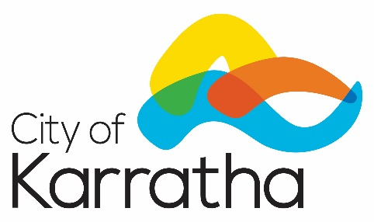

IMPOSITION OF FEES AND CHARGES

The City of Karratha intends to impose the following fees and charges not imposed as part of its budget:

- Indoor Play Centre – Special Program per session (up to max, per session) - $40 inc GST.

The reason for imposing these fees and charges is for the operation and management of the Indoor Play Centre.

These fees and charges apply from 15 December 2020.

Chris Adams
Chief Executive Officer

