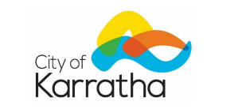

NOTICE OF
ANNUAL ELECTORS’ MEETING

The Annual Electors’ Meeting will be held on Monday, 24 March 2025 at the City of Karratha Council Chambers, Welcome Road, Karratha commencing at 5.30pm.

The purpose of this meeting is to discuss the contents of the City of Karratha Annual Report for the financial year ended 30 June 2024.

The meeting is open to members of the public.
Agenda papers (including the Annual Report) will be available at the meeting and via the City website: www.karratha.wa.gov.au

Virginia Miltrup
Chief Executive Officer

