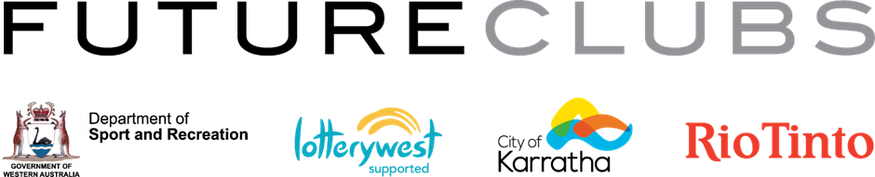

Long Service Recognition

Sport clubs and associations play an immensely important role in our community, supported by hardworking, dedicated members who volunteer their time to ensure a range of recreational options are available to the local community.
On Friday 27 October 2017, the FUTURECLUBS Club Development Program will be hosting the annual City of Karratha Community Sports Awards evening. The evening will acknowledge and celebrate the efforts of the City of Karratha’s community sporting groups - their volunteers, players, officials, coaches and sporting achievements over the past 12 months.
The recognition of long-serving volunteers within the City of Karratha sporting community, forms part of these awards.
Long Service Recognition is based on 20+ years of continuous service as an administrator or office bearer, provided to recognised community sporting clubs and associations based within the City of Karratha Local Government Area.

Nominations must be submitted by completing the below, accompanied by a signed letter of support from the local sporting club/association for which the nominee has volunteered for, endorsing their nomination.

Name of Nominee: __________________________________________________________________________

Nominee Resides within City of Karratha Local Government Area: YES / NO

Nominee has been a volunteer administrator or office bearer in a recognised sports club/association located within the City of Karratha Local Government Area: YES / NO

Years of Continuous Service: 20 25 30 35 40+

Committee Position/s Held: __________________________________________________________________

Club/Association Name:_____________________________________________________________________

Attached Letter of Support: YES / NO

NOMINATIONS TO
COMMUNITY ENGAGEMENT TEAM
EMAIL: grants.officer@karratha.wa.gov.au
HAND DELIVER: CITY OF KARRATHA ADMINISTRATION OFFICE
POST: PO Box 219, Karratha WA 6714
ENQUIRIES: Ph: (08) 9186 8555
THANK YOU FOR SUBMITTING A NOMINATION

