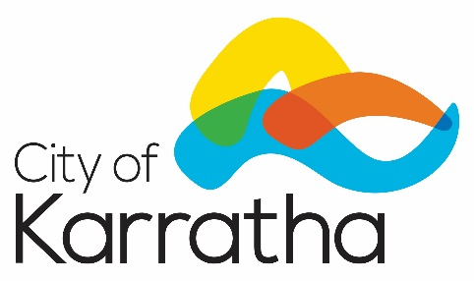

**NOTICE OF ADOPTION OF LOCAL LAW**

The City of Karratha resolved on 16 April 2018 to make the following local law:

**Activities in Thoroughfares and Public Places and Trading Amendment Local Law 2018**

The Purpose and Effect of the Amendment Local Law is to amend the existing City of Karratha Activities in Thoroughfares and Public Places and Trading Local Law 2017 to comply with the direction of the Joint Standing Committee on Delegated Legislation.

A copy of the local law may be inspected at or obtained from the City of Karratha Administration Building, Welcome Road, Karratha during normal operating hours. A copy is also available via [www.karratha.wa.gov.au/local-laws](http://www.karratha.wa.gov.au/local-laws).

A copy of the proposed local laws may be inspected at or obtained from the City of Karratha’s Administration Office located at Welcome Road, Karratha between 8.30am and 4.30pm weekdays, and at any public library within the City of Karratha during normal opening hours.

The local laws were gazetted in the Government Gazette on 29 May 2018 and will come into effect on 12 June 2018.

Chris Adams

**Chief Executive Officer**